UNIT 5

Q1) Explain data visualization with the help of example? What are the advantages of data visualization? / role of visualization in big data analytics  
Data visualization is the presentation of quantitative information in a graphical form. In simpler terms, it is the process of translating large datasets and metrics into charts, graphs, and other visuals that are easier for the human brain to understand and process. Good data visualizations emerge when communication, data science, and design effectively combine to offer key insights into complicated datasets in ways that are meaningful and intuitive. The resulting visual representation of data makes it easier to identify and share real-time trends, outliers, and new insights.

**Example of Data Visualization (using a Line Plot):** One common way to visualize data is by using plots and charts. Libraries like Matplotlib in Python are popular tools for creating a large number of graph and chart types, including 3D plots and animations. A graph is simply a visual representation of numeric data.  
Let's illustrate with a simple line plot showing how a value changes over a sequence of points.  
To create a basic line plot using Matplotlib's pyplot library in Python:  
1. Import the pyplot library, typically aliased as plt.  
2. Provide the data points (values) you want to plot.  
3. Use the plt.plot() function with your data.  
4. Use the plt.show() function to display the graph.  
This Python code would generate a line graph where the points (1,5), (2,7), and (3,4) are plotted and connected by lines. This visual representation makes it easy to see the trend or change in the y_values as x_values increase.  
To fully document graph, user usually have to resort to labels, annotations and legends. Each of these elements has a different purpose, as follows:   
1. Label: Make it easy for the viewer to know the name or kind of data illustrated.   
2.Annotation: Help extend the viewer's knowledge of the data, rather than simply identify it.   
3 . Legend: Provides cues to make identification of the data group easier.

**Advantages of Data Visualization:**  
Data visualization offers numerous benefits:  
1. **Enhanced Information Absorption:** It constructs ways for the human brain to absorb vast amounts of information quickly and efficiently regarding operational and business conditions.  
2. **Visualize Relationships and Patterns:** Visualizations help in easily identifying relationships and patterns within businesses or datasets that might be hidden in raw data.  
3. **Improved Collaboration and Sharing:** Graphs and charts make it easier to collaborate and share information and insights with stakeholders.  
4. **More Self-Service Functions:** Visual tools often provide more self-service functions for end users to explore data on their own.  
**Importance of Big Data Visualization:** Big data visualization is particularly important due to the sheer volume, velocity, and variety of big data. It helps:  
1. Provide clear knowledge about patterns in big data.  
2. Detect hidden structures and relationships within complex datasets.  
3. Identify areas that need to be improved within processes or systems.  
4. Understand which products are popular where, aiding in placement decisions.  
5. Clarify factors that influence human behavior by visualizing trends and correlations.

The three principal drivers behind the importance and use of data visualization technology are:  **Visual:** Data is represented graphically.  
**Insight:** Data visualization helps in understanding data and provides suggestions for action.  
**Sharing:** Advice and suggestions can be easily shared, leading to action.

Q2)**Explain challenges in big data visualization.** **OR What are the major challenges in visualizing the big data and how to overcome these challenges.** **OR Explain various challenges in big data visualization and explain the mechanism to overcome the challenges.**Big data analytics plays a key role in reducing the size and complexity of big data values, and visualization is an important approach to help gain a complete view of data and discover insights. However, visualizing big data, with its diversity and heterogeneity (structured, semi-structured, and unstructured), presents several significant challenges. Speed is often a desired factor for big data analysis, adding to these challenges.  
Here are some of the major challenges in big data visualization:  
1. **Visual Noise:** This occurs when there are too many objects in the dataset relative to the screen or visualization space. The density of data points makes it difficult for users to visually separate them as distinct objects on the screen, leading to an cluttered and unintelligible display.  
2. **Information Loss:** When visualizing large datasets, it's sometimes necessary to reduce the visible data points or aggregate data, which can lead to a reduction or loss of information from the original dataset.  
3. **Large Image Perception:** Data visualization methods are not only limited by aspects like the aspect ratio and resolution of the display device but also by fundamental physical perception limits of the human visual system in processing vast amounts of information simultaneously.  
4. **High Rate of Image Change:** In real-time or streaming big data scenarios, data can change very rapidly. Users need to observe this data and react to the intensity or rate of change on the display, which can be challenging if the visualization cannot keep up with the data flow or if the changes are too frequent to process visually.  
5. **High Performance Requirements:** Effective big data visualization requires significant computational power for processing, rendering, and interacting with massive datasets in a timely manner. Static visualization can be particularly challenging because it often has lower performance requirements compared to interactive or real-time visualizations needed for big data exploration.

**Potential Solutions to Some Challenges and Problems of Data Visualization:** While the challenges are significant, there are potential solutions to overcome them:  
a) **Meeting the Need for Speed:** One solution to address the performance requirements and speed needed for big data visualization is to deal with hardware limitations. This can involve increasing memory capacity and utilizing massive parallel processing capabilities provided by distributed computing environments.   
b) **Understanding the Data:** To effectively visualize big data, selecting the proper domain and expertise is crucial. Understanding the nature, structure, and context of the data helps in choosing appropriate visualization techniques and identifying what insights are important to display.   
c) **Displaying Meaningful Results:** To combat visual noise and information overload, a solution is to cluster data into smaller, more manageable groups that can be visualized effectively. Techniques like data aggregation and generalization (as discussed in data transformation) also help in reducing the volume of data displayed while retaining important patterns.   
d) **Dealing with Outliers:** Outliers can significantly distort visualizations and mislead interpretation. Solutions include removing outliers from the data before visualization or creating separate charts or visualizations specifically to highlight and analyze the outliers.  
------------------------------------------------------------------------------------------------------------------------------------------------------------------------------  
q3) commonly used data visualization functions from the matplotlib.pyplot  
Matplotlib's pyplot module is a widely used library in Python for creating static, interactive, and animated visualizations. It provides a collection of functions that mimic MATLAB's plotting interface, making it accessible and powerful for generating various types of plots. Here are some of the commonly used data visualization functions within matplotlib.pyplot:

**Basic Plotting Functions:**  
1. **plot(x, y):** This is a versatile function used to generate line plots, and also scatter plots by specifying the marker style. It can take various arguments to customize the line appearance, markers, and colors.  
2. **scatter(x, y):** Specifically designed for creating scatter plots, where individual data points are displayed as markers. Arguments allow for customization of marker size, color, and style.  
3. **bar(x, height):** Generates vertical bar plots. x represents the categories and height represents the value for each category. barh() is used for horizontal bar plots.  
4. **hist(x):** Computes and plots a histogram of a dataset x. It shows the distribution of a single variable by dividing the data into bins and counting the number of observations in each bin.  
5. **pie(x):** Creates a pie chart, which represents the proportions of different categories in a dataset as wedges of a circle.  
6. **boxplot(x):** Generates a box plot (or box-and-whisker plot) that displays the distribution of a dataset, showing the median, quartiles, and potential outliers.  
------------------------------------------------------------------------------------------------------------------------------------------------------------------------------  
q4) How data visualization help big data analytics ?  
• **Visual Representation:** Big data visualization offers a visual representation of vast amounts of data. The techniques used can range from simple line charts, histograms, and pie charts to more complex scatter plots, heat maps, and tree maps, and can even extend to 3D graphs depending on the goal and use case.

• **Facilitating Actionable Conclusions:** Big data analytics allows organizations to process captured data to derive viable and actionable conclusions related to causes, processes, and trends.

• **Support for Decision Making:** The results obtained from applying big data analytics and algorithms are primarily intended for decision-makers. Data visualization tools excel at presenting these captured data sets in a visual format without losing accuracy, precision, or the required level of aggregation, which serves the purpose of analysis effectively.

• **Specific Ways Data Visualization Helps:**

* **Enabling Quick Understanding:** It helps decision-makers understand the meaning of large amounts of data very quickly.
* **Capturing Trends:** Using appropriate visualization techniques makes it easy to recognize trends.
* **Revealing Patterns:** It helps identify correlations and unexpected connections that might not be found through specific questions alone.
* **Effective Communication:** It provides a highly effective way to communicate any insights that surface from the data to others.

------------------------------------------------------------------------------------------------------------------------------------------------------------------------------  
q5) Explain any four types of data visualization with example. OR Describe different types of data visualization.  
**1. Multidimensional / 2D Area Visualization**  
This type of visualization focuses on displaying information across two-dimensional spaces, often distorting map space to represent data like travel time or population.  
**Cartogram:** Distorts the area or shape of a map to represent a specific variable. For example, a cartogram might show countries sized according to their population rather than their land area.  
**Choropleth:** Uses different shades or patterns to represent statistical measurements over a geographical area, such as population density or website visitors per city.  
**Dot Distribution Map:** Employs dots or symbols on a map to represent the presence and density of a phenomenon, displaying spatial patterns.

**2. Temporal Visualization**  
Temporal visualization is used to display data that changes over time.  
**Pie Chart:** While also used for proportions, the text mentions it in the context of temporal data where the circle is divided into sectors representing numeric proportions at a specific point or period in time.  
**Histogram:** Groups data into ranges (bins) and plots them as connected bars. The width of the bar represents the range, and the height is proportional to the frequency or percentage of data within that range. This can show the distribution of data over time if the data is time-series based.  
**Scatter Plot:** Displays a collection of points for two variables. When one of the variables is time, it can show trends or relationships over a period

**3. Hierarchical Visualization**  
This type of visualization represents data that has a hierarchical structure, showing relationships between parent and child elements.  
**Dendrogram:** A tree-like diagram used to represent the clusters generated by hierarchical clustering analysis.  
**Ring Chart:** A multi-level pie chart that uses nested circles to show hierarchical relationships in data.  
**Tree Diagram:** Represents data or a hierarchy in a graph format, which can be visualized from left to right or top to bottom.

**4. Network Visualization**  
Network visualization focuses on displaying the connections and relationships between entities in a network.  
**Alluvial Diagram:** A flow diagram that visualizes changes in network structure over time.  
**Node-Link Diagram:** In this common network representation, entities (nodes) are visualized as dots or circles, and the connections between them (links) are represented as lines.  
**Matrix:** Shows the relationship between two to four groups of information in a grid format, providing information about the connections or interactions between elements in those groups.  
-------------------------------------------------------------**-----------------------------------------------------------------------------------------------------------------  
q6) different techniques of big data visualization**  
1. Scatter plot:  
• Scatter diagram is also called scatter plot, X-Y graph. The scatter plot is the model of data visualization depicting two sets of unconnected dots as parameter values.  
• Scatter plots which use horizontal and vertical axes to plot data points and display how much one variable is affected by another. The position of each dot on the horizontal and vertical axis indicates values for an individual data point  
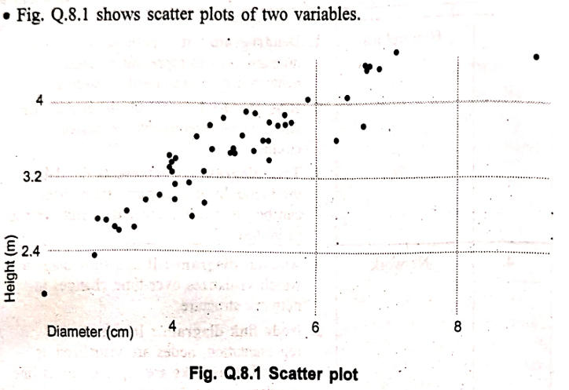  
The example scatter plot above shows the diameters and heights for a sample of fictional trees. Each dot represents a single tree; each point's horizontal position indicates that tree's diameter (in centimeters) and the vertical position indicates that tree's height (in meters).

Histogram:  
• In a histogram, the data are grouped into ranges (e.g. 10-19, 20-29) and them plotted as connected bars. Each bar represents a range of data. The width of each bar is proportional to the width of each category and the height is proportional to the frequency or percentage of that category.  
• It provides a visual interpretation of numerical data by showing the number of data points that fall within a specified ranges of values called "bins".  
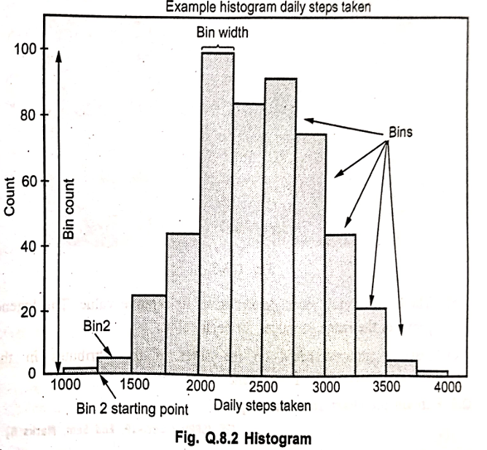

• Histograms can display a large amount of data and the frequency of the data values. The median and distribution of the data can be determined by a histogram. In addition, it can show any outliers or gaps in the data.  
Matplotlib provides a dedicated function to compute and display histogram : plt.hist()

Heat map:  
• Use a heat map visualization to visualize the relationship between columns, represented in a matrix type view. A heat map visualization uses color and intensity of the color to show the relationship between two columns.  
• A heat map visualization is a combination of nested, colored rectangles, each representing an attribute element. Heat Maps are often used in the financial services industry to review the status of a portfolio.  
• For example, this heat map visualization shows the average customer lifetime value by gender and education.  
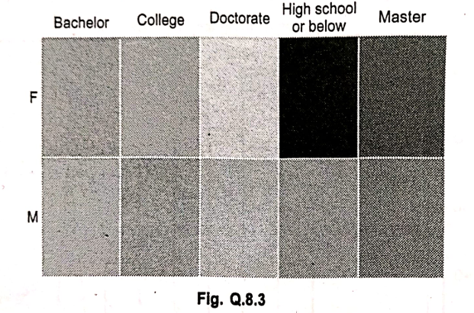

• The rectangles contain a wide variety and many shadings of colors, which emphasize the weight of the various components. In a heat map visualization:  
a) The size of each rectangle represents its relative weight. The legend provides information about the minimum and maximum values  
b) The color of each rectangle represents its relative value. The legend provides the range of values for each color.   
c) Data is grouped based on the order of the attributes in the Grouping area of the Editor panel.

Pie chart :  
• A type of graph in which a circle is divided into sectors that each represent a proportion of the whole. Each sector shows the relative size of each value.  
• A pie chart displays data, information and statistics in an easy to read "pie slice" format with varying slice sizes telling how much of one data element exists. The main use of a pie chart is to show comparisons. Fig. Q.9.1 shows pie chart.  
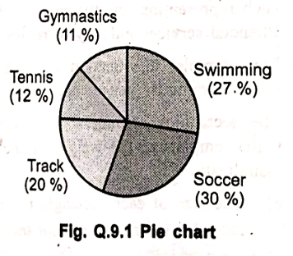  
• Various applications of pie charts can be found in business, school and at home.  
Gymnastics (11%)  
Tennis (12%)  
Swimming (27%)  
Track (20%)  
Soccer (30%)  
For business pie charts can be used to show the success or failure of certain products or services.  
• At school, pie chart applications include showing how much time is allotted to each subject. At home pie charts can be useful to see expenditure of monthly income in different needs.  
• Reading of pie chart is as easy as figuring out which slice of an actual pie is the biggest.  
• Pie charts can be drawn using the function pie() in the pyplot module. The below python code example draws a pie chart using the pie() function. By default the pie() function of pyplot arranges the pies or wedges in a pie chart in counter clockwise direction  
-------------------------------------------------------------**-----------------------------------------------------------------------------------------------------------------  
q7)** Explain different tools for data visualization. OR Explain different data visualization tools.  
Data visualization tools include Google Charts, Tableau, Grafana, Chartist.js, FusionCharts, Datawrapper, Infogram, ChartBlocks, and D3.js.  
**Pentaho:**  
Pentaho is a business analytics platform that tightly couples data integration with business analytics. It provides a single, seamless platform to solve data integration challenges and deliver business analytics. Key features and aspects highlighted include:  
1. A Java-based data integration engine that integrates with MapR Hadoop for automatic deployment across a Hadoop cluster, leveraging parallel processing and high availability.  
2. An open-source heritage that drives innovation in a modern, integrated, embeddable platform for analytics, including big data requirements.  
3. Visual tools for extracting and preparing data, along with analytics, within a single platform.  
4. A modern, simplified, and interactive approach that empowers business users to access, discover, and blend various types and sizes of data.  
5. Capabilities ranging from basic reports to predictive modeling, allowing users to analyze and visualize data across multiple dimensions with minimized dependence on IT.  
6. It is a web application that allows users to publish and manage reports within an enterprise business intelligence system.  
7. Offers capabilities including the management and execution of Pentaho reports, enabling information technologists to utilize reporting without writing code.  
8. Provides scheduling, background execution, security, and more for publishing and executing reports.

**Datameer:**  
Datameer's Flipside is described as providing simple, highly accessible, visual data profiling that helps users easily spot outliers in data quickly and early in the analytics process.  
Datameer runs natively on Hadoop.  
All Datameer functionality occurs across three major components:   
**The Datameer server (Conductor):** This server orchestrates and manages the configuration of all jobs performed on the Hadoop cluster. It also hosts the web app for user interaction via the software's web UI, providing real-time feedback during the design phase using intelligent previews generated by Smart Sampling technology.  
**Database for metadata storage:** Datameer uses a database to store all metadata.  
**Hadoop cluster:** This provides persistent storage for all data, pre-views, and other job artifacts. It also serves as a big data processing framework for executing long-running operations. Datameer's design leverages Hadoop clusters for resource-intensive processes, allowing it to scale up and out easily by distributing work across the entire cluster.

**DataHero:**  
DataHero is described as the world's first truly self-service data visualization and data dashboard platform. Its aim is to turn siloed data into deep insights using powerful data visualization tools that are understandable for everyone on a team. With DataHero, users can easily connect to cloud services, create stunning visualizations, and build automated KPI dashboards to facilitate deeper insights and better decisions.

**Dygraphs:**  
Dygraphs is an open-source JavaScript library specifically designed to produce interactive, zoomable charts of time series data. It is built to display dense data sets and empower users to explore and interpret them. Dygraphs is capable of handling large data sets with millions of plot points and works across all browsers, including zoom functionality for mobile devices.

Some of the features of Dygraphs mentioned are:

* Plots time series without requiring an external server or flash.
* Works in Internet Explorer (using excanvas).
* Lightweight (69 kb) and responsive.
* Displays values on mouseover, making interaction easily discoverable.
* Supports error bands around data series.
* Offers interactive zoom.
* Displays annotations on the chart.
* Has adjustable averaging periods.
* Can intelligently chart fractions.
* Offers customizable click-through actions.
* Compatible with the Google Visualization API.
* Intelligent defaults make it easy to use.

Q8) **JasperReport**  
JasperReports is described as a powerful open-source reporting package. However, the image notes that generating reports with data from multiple sources is challenging and often impossible without the enterprise version.  
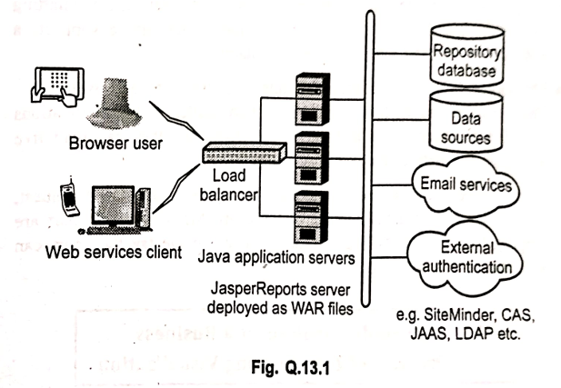  
Key points about JasperReport from the images include:

* JasperReports is an open-source Java reporting engine and a Java class library. It is intended for Java developers who need to add reporting capabilities to their applications.
* The main purpose of JasperReports is to create page-oriented, ready-to-print documents in a simple and flexible manner.
* JasperReports Server is a stand-alone and embeddable reporting server.
* It provides reporting and analytics capabilities that can be embedded into web or mobile applications. It operates as a central information hub for the enterprise, delivering mission-critical information on a real-time or scheduled basis to browsers, mobile devices, or email inboxes in various file formats.
* JasperReports Server is optimized to share, secure, and centrally manage your Jaspersoft reports and analytic views.
* When generating a report, the JasperReports engine obtains data from datasources, which are structured data containers. Data can be obtained from databases, XML files, arrays of objects, and collections of objects.
* JasperReports has a <style> feature that helps control text properties in a report template. This element is a collection of style settings declared at the report level, including properties like foreground color, background color, whether the font is bold, italic, or normal, the font size, a border for the font, and many other attributes.

-------------------------------------------------------------**-----------------------------------------------------------------------------------------------------------------  
q9)** **Google Chart API:**

The Google Chart API is described as an interactive Web service that creates graphical charts from user-supplied data.

* Google servers create a PNG image of a chart based on data and formatting parameters specified by a user's HTTP request.
* The service supports a wide variety of chart information and formatting.
* The Google Chart Tools enable adding live charts to any web page. They offer advantages such as a rich gallery of visualizations and interactive charts, and they can read live data from a variety of data sources.
* Users embed the data and formatting parameters in an HTTP request, and Google returns a PNG image of the chart.
* Many types of charts are supported, and by making the request into an image tag, the chart can be included in a web page.

-------------------------------------------------------------**-----------------------------------------------------------------------------------------------------------------q10) analysis of a business problem of Zomato using visualization**. Founded in 2008 Zomato is a major food delivery aggregator with a markdown cap of 1 Trillion INR. It started as Foodiebay, a restaurant recommendation product, at its peak, it has 35000 menus and 60 Lakh monthly revenue. Foodiebay.com reroutes to zomato.com now.

Zomatlo offered customer: A solution to have access to all the restaurants through a database, the type of food menu, location of the eateries and most importantly their feedback and the reviews.

Zomato Kitchens under the banner of Zomato Infrastructure Services provides cloud kitchens to the best and reliable restaurants only. It provides kitchen equipment, tech stack, POS, and delivery, and tracking systems. Zomato earns a share of restaurants profit, thus making sure it's a win-win situation.

Zomato is dynamic on Instagram, Facebook and Twitter. Beginning at July 2019, it has 154 K followers on Instagram, 1,899,405 supporters and 1.42 Million lovers on Twitter.

The dataset of restaurant was carried out by the researchers based on Zomato registered restaurant through Zomato API and it is publicly availabe on "www.kaggle.com". The dataset has multiple different variety of columns which are used to analyze and identify which city has highest number of good restaurants based on ratings, votes and analyzing pattern of expensive restaurant with quality of food.  
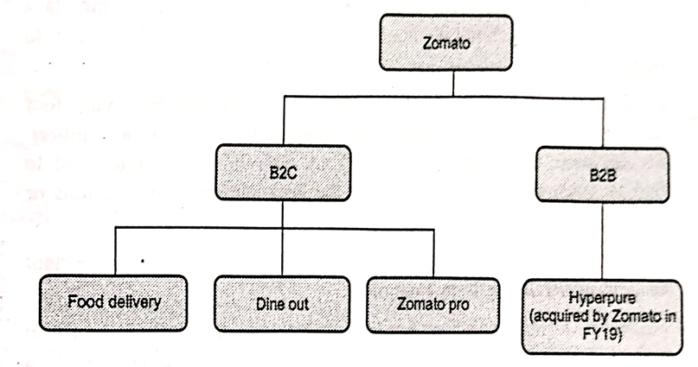  
-------------------------------------------------------------**-----------------------------------------------------------------------------------------------------------------  
q11) analytical techniques discussed in the context of big data visualization**Various analytical techniques are used in big data processing to extract, collect, store, process, and analyze the large volume, velocity, and variety of data. While the images delve into the analytical techniques themselves, the implication is that the results of these analyses are often then visualized to gain insights.  
**Machine Learning:** Machine learning algorithms take examples and produce a program that performs a task. The program can be very complex and may contain millions of numbers. When done correctly, the program can work for new, unseen cases. The main goal of machine learning is to devise learning algorithms that operate automatically without human intervention. This paradigm can be seen as "programming by example." Another goal is to develop computational models of human learning and perform computer simulations. Ultimately, machine learning aims to build computer systems that can adapt and learn from their experience.  
**Algorithm:** An algorithm is a sequence of instructions used to solve a problem on a computer. It transforms input into output.  
**Supervised Learning:** This is a machine learning task where an algorithm infers a function from supervised training data. The training data includes a set of examples with known output. The goal is for the supervised learner to predict the output behavior of a system for any new input values after the initial training phase.  
**Unsupervised Learning (or Self-Organized Learning):** In contrast to supervised learning, this approach does not require an external teacher. During the training session, the neural network (mentioned in the text) receives different input patterns, discovers significant features within these patterns, and learns how to classify input data into appropriate categories. Unsupervised learning algorithms aim to learn rapidly and are used in real-time. It is frequently employed for tasks like data clustering and feature extraction.     
**Reinforcement Learning:** This is an advanced machine learning technique based on probability theory. Mapping is done based on the input received and changes in the environment around it.  
**Deep Learning:** Also considered an advanced machine learning technique, deep learning utilizes multiple processing layers to produce a non-linear response based on input data. It is mentioned that there are many small processors called neurons working in parallel in data processing within deep learning.  
**Predictive Analytics:** This technique refers to making predictions based on past experience. It utilizes both data mining and machine learning.  
**Association Rule Learning:** This technique is used to identify interesting relationships between different attributes within large datasets.  
-------------------------------------------------------------**-----------------------------------------------------------------------------------------------------------------  
q12)** **Explain data visualization with Tableau. Or Explain data visualization with Tableau.**Tableau is one of the fastest evolving Business Intelligence (BI) and data visualization tool. Tableau Server is a business intelligence application that provides browser-based analytics anyone can use. It's a rapid-fire alternative to the slow pace of traditional business intelligence software. A business intelligence and data visualization tool allowing users to make sense of their data through interactive charts, graphs, and diagrams.

Why use Tableau ?   
1. Traditional BI tools require complex installations   
2. Rapid results to useful information   
3. Easy to use for all skill levels   
4. Excellent migration path for Excel users   
5. It can use many different sources of data.

Tableau uses a visual query language. The tableau data engine is a breakthrough in-memory analytics database designed to overcome the limitations of existing databases and data silos.   
Capable of being run on ordinary computers, it leverages the complete memory hierarchy from disk to Ll cache. It shifts the curve between big data and fast analysis.   
Tableau allows the users to directly connect to databases, cubes, and data warehouses etc. After analyzing the data, the results can be shared live with just a few clicks. The dashboard can be published to share it live on web and mobile devices.   
Tableau is relatively new in the Business Intelligence market but its market share is growing on a daily basis. It is being nearly all industries, from transportation to healthcare.   
Tableau Software does not support expanded analytics such as Box plots, network graphs, tree maps, heat-maps, 3D-scatter plots, Profile Charts or data relationships tool which allow users to mine data for relationships like another data visualization software does.  
-------------------------------------------------------------**-----------------------------------------------------------------------------------------------------------------  
q13)** 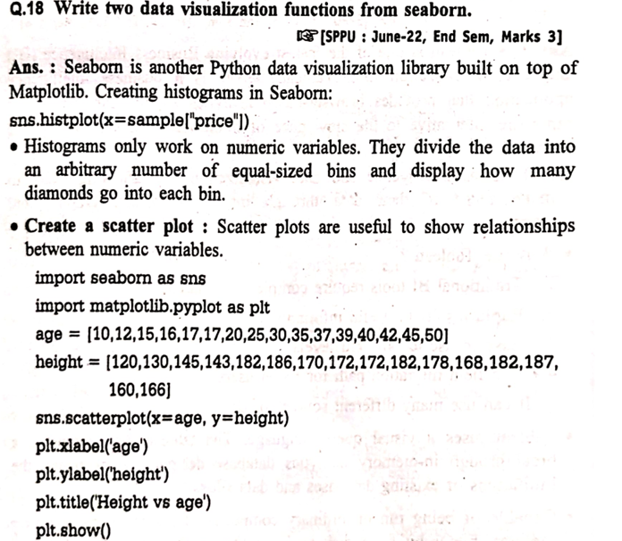  
-------------------------------------------------------------**-----------------------------------------------------------------------------------------------------------------  
q14) Candela**Candela is described as an open-source suite of web visualization components that emphasize scalable, rich visualizations. It is built using the Python language and utilizes a normalized API for use in real-world data science situations.Candela is an interoperable suite of web visualization components, providing libraries for JavaScript, and packages for Python and R. The tool works on Kitware's resonant platform and offers a range of elements for data visualization, allowing users to create super-rich visualizations that are scalable and available within a normalized API.

Specifically, Candela is a JavaScript library that provides reusable visualization components for the web. Key aspects highlighted include:  
1. Reusable: Candela offers a general API not tied to any particular framework or library, making components created with it easily portable from application to application.  
2. Visualization: The general API provides flexibility, with the main requirement being that the user must implement a function called render() which carries out the visualization semantics.  
3. Components: It uses object-oriented concepts to implement the notion of a visualization component.  
4. For the web: Candela utilizes modern JavaScript, leveraging features and modern tooling to produce a library that can be used for visualization almost anywhere on the web.

**Q15) D3.js**

D3.js (or D3 for Data-Driven Documents) is a powerful open-source JavaScript library for manipulating documents based on data. It allows you to bring data to life using HTML, SVG, and CSS. Unlike many other visualization tools that offer pre-built chart types, D3.js provides a low-level, flexible approach that gives you fine-grained control over the visual representation of your data.

Key aspects of D3.js include:

* **Data-Driven:** D3.js binds data to a Document Object Model (DOM), allowing you to create dynamic and interactive data visualizations.
* **Flexibility and Control:** It doesn't provide standard chart types out-of-the-box. Instead, it offers the building blocks to create almost any kind of visualization imaginable, from simple bar charts to complex network diagrams and interactive maps.
* **Web Standards:** D3.js leverages widely used web standards like HTML, SVG, and CSS, making visualizations accessible and performant across different browsers.
* **Interactive:** It is well-suited for creating interactive visualizations, allowing users to explore data through zooming, panning, hovering, and other interactions.
* **Large Community and Ecosystem:** D3.js has a large and active community, resulting in a wealth of examples, tutorials, and plugins that extend its capabilities.